Surname, First name |  | SELVARATNAM, SITPAH
Address | 101, Jalan Ara, Bangsar Baru  Bangsar, 59100 Kuala Lumpur, Malaysia
Telephone | + 603 – 2287 3540
Fax | + 603 – 2284 8892
Email | sitpah@tommythomas.net
Nationality/ Date of Birth | Malaysian / 27th May 1965
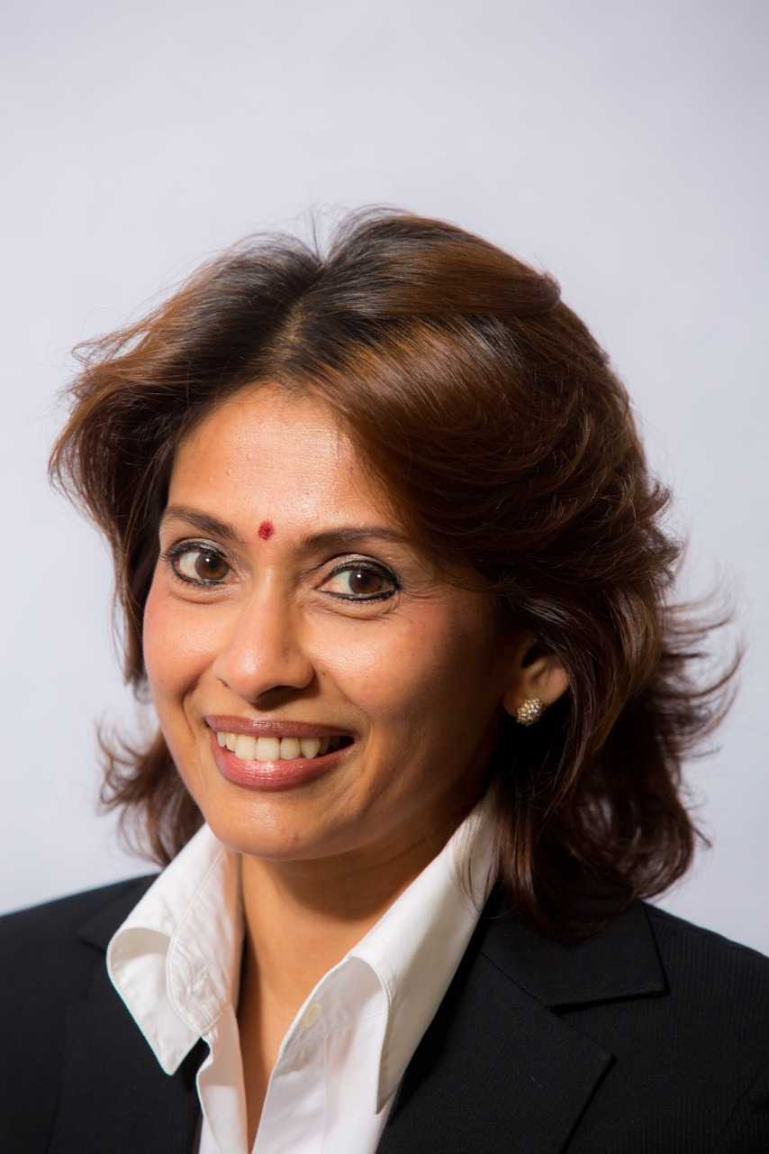

Educational/Professional Memberships
- Diploma in International Commercial Arbitration –Chartered Institute of Arbitrators, Keble College, Oxford [April 2008];
- LLM University of Cambridge, Queens’ College [June 1991];
- Advocate & Solicitor, West Malaysia [July 1990];
- Degree of Utter Barrister, Honourable Society of Lincoln’s Inn [July 1989];
- LLB University of Wales, Cardiff (UWIST), First Class Honours [June 1988].

- Panel of Arbitrators, Kuala Lumpur Regional Centre for Arbitration [KLRCA];
- Panel of Arbitrators, Singapore International Arbitration Centre [SIAC];
- Fellow, Chartered Institute of Arbitrators;
- Fellow, Malaysian Institute of Arbitrators;
- Member, Malaysian Mediation Centre;
- Chair, Maritime Arbitration Working Committee of the KLRCA;
- Member, Admiralty and Maritime Law Reform Taskforce empanelled by the Malaysian Judiciary;
- Co-Chair, Shipping and Admiralty Committee of the Malaysian Bar Council;
- President, International Malaysian Society of Maritime Law [IMSML];
- Chair, Maritime Law Committee of the Inter-Pacific Bar Association [IPBA];
- Member, International Association of Defense Counsel [IADC].

Current Position
Consultant to the law firm of Tommy Thomas; Counsel; Arbitrator.

Professional Experience
In excess of 25 years of experience in dispute resolution. Settling cause papers, appearing in superior and appellate Courts in Malaysia and in arbitration as Counsel; and advising on :

- admiralty, shipping and maritime law, and international trade;
- corporate receivership, liquidation and special administration;
- banking, company and commercial litigation.

Rendering written expert evidence in the High Courts of Singapore and Durban, South of Africa on Malaysian international trade, shipping and admiralty laws.

Arbitration Experience
- 4 appointments by the KLRCA as Sole Arbitrator in domestic disputes involving a charterparty, medical consultancy service contract, and sale of insurance business assets and liability contract, respectively.
- 12 appointments by the Singapore International Arbitration Centre (SIAC) as Sole Arbitrator in international charterparty and trade disputes.
- 2 Parties’ mutual nomination as Sole Arbitrator in an international charterparty dispute, administered by the KLRCA.
- Presiding Arbitrator in a 3 member Tribunal on an international ship building dispute.

Handed down 8 awards; 5 in relation to SIAC appointments, and 3 in relation to KLRCA administered arbitration. 6 pending references.
Publications
Publication in the Malaysian Law Journal, Bar Council and KLRCA’s publications, of papers presented at various forum and interviews by local media.

Languages
English, Bahasa Malaysia

